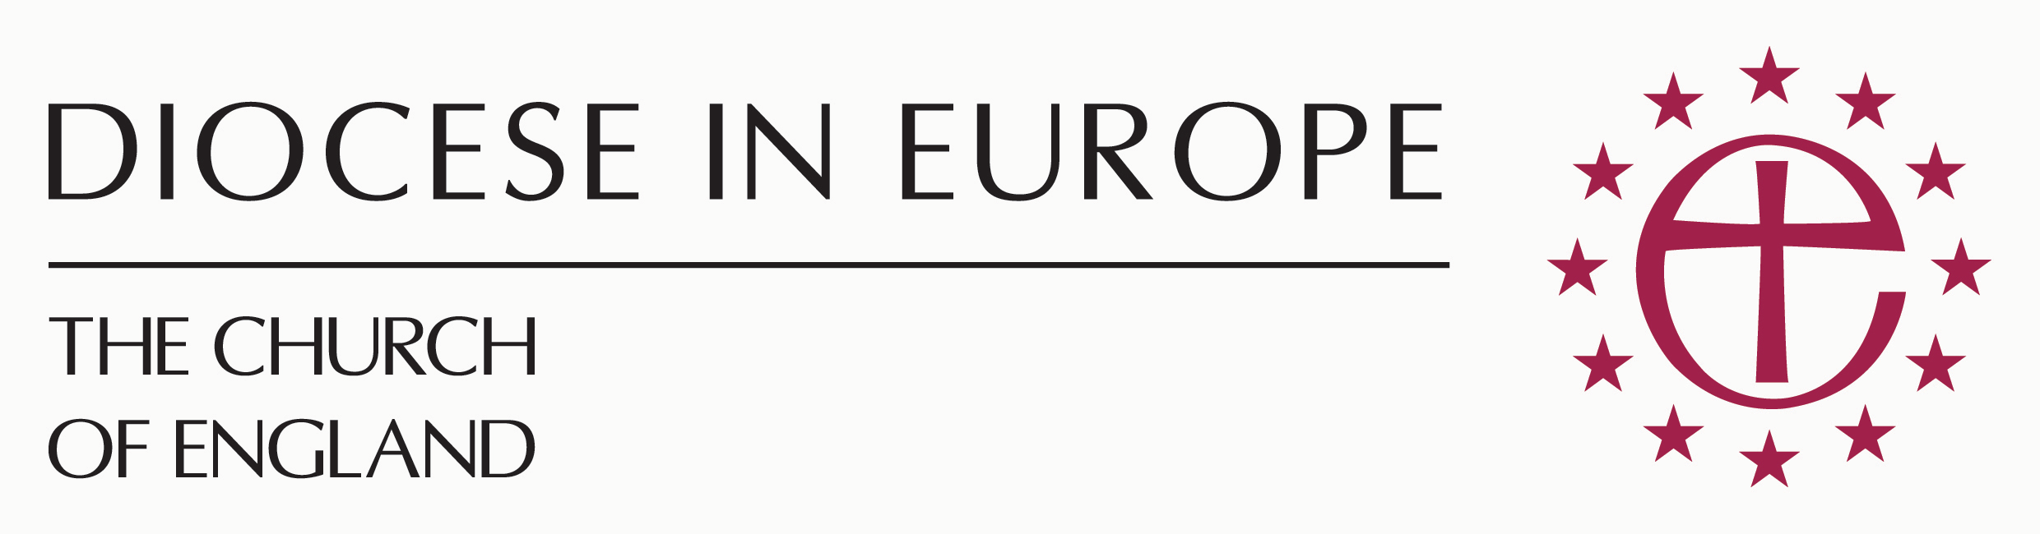
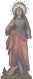
Santa Margarita
ANGLICAN CHURCH IN MENORCA
Calle Stuart 20, Apartado 102, 07720 Es Castell,
Menorca, Balearic Islands, Spain

Ceremony*/Wedding Blessing*/Renewal of Marriage Vows
Husband Wife
Full Name
(Please print)
Date & Place of birth
Nationality
Address

Phone

e-mail
Father’s name

Mother’s maiden name
Have you been baptised?
Where?
When?
Have you been previously married?
If so, was the previous marriage annulled or terminated by death or divorce?
Date and place of Civil Marriage

Date and time of proposed ceremony

Place of proposed ceremony

I certify that to the best of my belief the answers to the above questions and the information
given are correct.

Date: ___________________ Signed: (Husband) _______________________________

Signed: (Wife) ___________________________________

Additional Information
The fees for wedding blessings are stipulated by the Church of England: we request a donation of 500 euros, or the equivalent in sterling, which is in addition to (if applicable) any costs attached to using premises other than the church. It is possible for residents of the UK to apply Gift Aid to this donation.

Information regarding other services (readings, music, flowers, etc.) can be provided, although the chaplaincy is not able to act as a full wedding planner, simply as provider of information.

Rehearsal:

It is necessary to have a Wedding Blessing rehearsal beforehand to allow the Chaplain to go through the ceremony with you.

All donations and expenses should be paid at the rehearsal, or by bank transfer before the rehearsal, with a receipt and/or transfer identification number provided for the benefit of the church treasurer.
- Please bring with you either your original or a photocopy of your Civil Marriage certificate for the Chaplain to see, thank you.

*Please note that the Ceremony and the Wedding Blessing do not constitute a legally recognised contract. This is a blessing of a Civil Marriage.

Please return the completed form to the Wedding Blessing Coordinator, Mrs Margaret Jones:

Email: mdandjtj@gmail.com

Or, by post, to:
Wedding Blessing Coordinator
Iglesia Santa Margarita,
Anglican Church in Menorca,
C/Stuart 20,
07720 Es Castell,
Menorca, Spain.

